**<LANGUAGE TRANSLATION SYSTEM>**

*A*

*Mini Project Report*

*Submitted in partial fulfilment of the Requirements for the award of the Degree of*

# BACHELOR OF ENGINEERING

IN

# INFORMATION TECHNOLOGY

By

#### <1602-21-737-001><P.ABHIGNYA>

**<1602-21-737-017><R.HARINI>**

**<1602-21-737-037><G.NIHARIKA>**

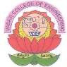

# Department of Information Technology Vasavi College of Engineering (Autonomous)

**ACCREDITED BY NAAC WITH 'A++' GRADE**

# (Affiliated to Osmania University and Approved by AICTE) Ibrahimbagh, Hyderabad-31

**2023**

# Vasavi College of Engineering (Autonomous)

**ACCREDITED BY NAAC WITH 'A++' GRADE**

# (Affiliated to Osmania University and Approved by AICTE) Hyderabad-500 031

**Department of Information Technology**



# DECLARATION BY THE CANDIDATE

#### We, <ABHIGNYA>, <HARINI>,and <NIHARIKA>,

bearing hall ticket numbers, **<1602-21-737-001>, <1602-21-737-017>** and **<1602-21-737-037>**, hereby declare that the project report entitled **“LANGUAGE TRANSLATION SYSTEM”** is submitted in partial fulfilment of the requirement for the award of the degree of **Bachelor of Engineering** in **Information Technology**

This is a record of bonafide work carried out by us and the results embodied in this project report have not been submitted to any other university or institute for the award of any other degree or diploma.

**<ABHIGNYA>**

**<1602-21-737-001>**

**<HARINI>**

**<1602-21-737-017>**

**<NIHARIKA>**

**<1602-21-737-037>**

(Faculty In-Charge) (Head,Dept of IT)

**ACKNOWLEDGMENT**

We extend our sincere thanks to Dr. S. V. Ramana, Principal, Vasavi College of Engineering for his encouragement.

We express our sincere gratitude to Dr. K. Ram Mohan Rao, Professor & Head, Department of Information Technology, Vasavi College of Engineering, for introducing the Mini-Project module in our curriculum, and also for his suggestions, motivation, and co-operation for the successful completion of our Mini Project.

We also want to thank and convey our gratitude towards our mini project coordinators <Haseeba Yaseen> and

<Rajyalaxmi S> for guiding us in understanding the process of project development & giving us timely suggestions at every phase.

We would also like to sincerely thank the project reviewers for their valuable inputs and suggestions.

ABSTRACT

A language translator is a device or software program designed to convert text or speech from one language to another. It is used for facilitating communication and understanding between people who speak different languages. The translator works by analyzing the input text or speech, identifying the language, and then converting it into the target language using a database of predefined linguistic rules and phrases. The accuracy and quality of translation may vary depending on the complexity of the language and the quality of the software or device. As English is an International language, it becomes crucial to understand it , so our project focuses on the English text translation into native languages for proper communication between nations. It makes learning and language translation easy and facilitates stress-free communication. The system will also be able to evaluate language translation to determine their suitability for everyday conversation.

TABLE OF CONTENTS

S No. Contents Page No.

1. INTRODUCTION 1-4

* 1. Purpose

1.2 Motive

1.3 Features

1. TECHNOLOGY 4-5
   1. Software Requirements
   2. Hardware Requirements

1. PROGRAMMING LANGUAGE 6
   1. Python

1. WORKING 7
2. PROPOSED WORK 8-10
   1. Use Case Diagrams
   2. Use Case Descriptions
   3. Activity Diagram
3. IMPLEMENTATIONS 11-18
   1. Execution Of Program
   2. Outputs

7. ADDITIONAL KNOWLEDGE GAINED BY 19-20

THIS PROJECT

7.1 ttk

7.2 Message Box

7.3 Googletrans

7.4 Translate

7.5 Threads

7.6 OS

8. CONCLUSION 21

9. FUTURE SCOPE OF THE PROJECT 22

10. REFERENCE WORK 23

1.INTRODUCTION

A language translation system is a application that can be utilized for translating from one language to another. The problem of language difference has hindered effective information communication over the years. This traditional approach used for solving the problem of language differences has not been productive and favorable. Language Translator is a tool to translate text, words, phrases from one language to any other language. It is like a dictionary where we can translate the text . This project helps in translating the text in other languages easily. Language Translation is process of reworking text from one language into another to maintain the original message and communication.

A Language Translation System can be utilised for translating from English to any other dialect. The problem of language difference has hindered effective information communication over the years. There have been difficulties in information communication amid countries over the years. In modern times, language interpreters must understand and speak both the language been translated to and verse-visa. This traditional approach used for solving the problem of language differences has not been productive and favourable. Also, the teaching of different languages can be difficult due to language difference problems. The individual will also have to be taught by a tutor who will incur extra expenses and may not be the most efficient and favourable method. Therefore, we came up with this project in order to make learning and language translation easy and facilitates stress-free communication. The proposed Language Translation System uses Google's real-time translation API natural language processing with Python programming language to develop the project.

1

The most used languages globally (i.e., English, Spanish, Arabic, Hindi, French, and Chinese) among these languages we selected English language as the Input language. This can also be useful for Tourists for communication purposes, thus allowing them to integrate with the local people and access the right information. The system will also be able to evaluate language translation to determine their suitability for everyday conversation. The Language Translation System consists of total 108 Languages almost covering all the important languages including both National and Foreign languages .

Language translators have numerous practical applications, such as facilitating communication between individuals or businesses, improving cross-cultural understanding, and helping with travel and education in foreign countries. However, it is important to note that language translation is not an exact science and errors or inaccuracies can occur. Therefore, it is always recommended to have the translated text reviewed by a native speaker of the target language.

1.1Purpose

The goal of translation practice for non-specialists is to found the language skills of the learner , to refine their thematic and cultural knowledge and to encourage them to think and to react .The objective of language translator are:

1.Develop a system which able to do conversion between the

Languages.

2.Provide an easy and simple for translation.

3.Endow good experience to the user.

4.Translate almost each language.

2

1.2 Motive of Language Translation System

Translation is one of the simplest and effective ways to another language easily. According to Technitrad , translation services provide the ability for two parties to communicate and exchange ideas from different countries. They can break down spoken word or translate documents to ensure that both parties understand each other in every format of communication . This strengthens relationships between individuals improving business relationships to expanding their social network.

There is great importance and significance when it comes to translation for everyone. Solely operating in English can hold back companies and businesses. When you understand the importance of translation for everyone, you will be able to see it as a necessary and worthy investment. For that, you will also need a professional translator or a company that offers translation services.

Translation is necessary for the spreading new information, knowledge, and ideas across the world. It is absolutely necessary to achieve effective communication between different cultures. In the process of spreading new information, translation is something that can change history.

It is the only medium by which certain people can know different works that will expand their knowledge of the world. For example: TED talks are so big on the importance of translation that they have a specific project that will allow people from around the world to listen to their talks and hear from the best educators in the world.

3

1.3 Features of Language Translation System

* Linguistic Expertise.
* Appreciation for Other Cultures.
* Awareness of the Evolution of Language.
* Area of Specialization.
* Attention to Detail.
* Ability to Accept Criticism.
* Time Management Skills.
* Passion for Language.

2.TOOLS AND TECHNOLOGY

2.1 Hardware Requirements

To excess this website, its only needed a PC/Laptop/Mobile with an integrated and updated web browser.

1.Desktop Browsers: Safari, Chrome, Firefox , Opera,IE9+.

2.Mobile Browsers: Android, Chrome Mobile, iOS Safari.

3.Active Internet Connection.

* 1. Software Requirements
* **Python**

1.Python 3.11

4

* **Libraries**

To proceed with the project we installed the Tkinter Module, gTTs (Google Text-To-Speech), pyttsx3 and Googletrans library using the following commands.

1. Tkinter Module – This is the module to create easy GUI in Python.

1. Messagebox – This is for displaying a message box.

3.Googletrans – This is for importing a number of languages that we will be using during the project to translate from one to another.

4.gTTs (Google Text-To-Speech)- a Python library and CLI tool to

interface with Google Translate ' s text-to-speech API.

5. **Pyttsx3** - is a text- to- speech conversion library in python.

* **Operating System**

1.Windows 10

5

3.PROGRAMMING LANGUAGE

3.1 Python

Python is an interpreted high-level general-purpose programming language. Its design philosophy emphasizes code readability with its use of significant indentation. Its language constructs as well as its object-oriented approach aim to help programmers write clear, logical code for small and large-scale projects . Python is dynamically-typed and garbage-collected.

It supports paradigms, multiple programming including structured (particularly, procedural), object-oriented and functional programming. It is often described as a "batteries included" language due to its comprehensive standard library . Python consistently ranks as one of the most popular programming languages.

Python uses dynamic typing and a combination of reference counting and a cycle-detecting garbage collector for memory management. It also features dynamic name resolution (late binding), which binds method and variable names during program execution. Python's design offers some support for functional programming in the Lisp tradition. It has filter, map and reduce functions; list comprehensions, dictionaries, sets, and generator expressions.

Python was designed to be highly extensible (with modules). This compact modularity has made it particularly popular as a means of adding programmable interfaces to existing applications. Python strives for a simpler, less-cluttered syntax and grammar while giving developers a choice in their coding methodology. When speed is important, a Python programmer can move time-critical functions to extension modules written in languages such as C, or use PyPy, a just-in-time compiler. Python's developers aim to keep the language fun to use.

6

4.WORKING

The Language Translation System consists of a dialog box

that contains a List of different output languages where we can select the desired output language of our choice. The Input Language is English by-Default so just we will be able to enter the text in the TextArea provided below the Input language. After typing the input text or we can also copy and paste the contents into that TextArea, after doing it, simply by pressing the Translate button which is at the bottom of the dialog box, we can see the output of the given input Text got translated into the output language that we selected. Additionally we can also we able to hear the audio of input and output texts. Overall , this tool can easily translates the given text into desired language and it is very efficient as we can get the output within a few seconds.

7

5.PROPOSED WORK

5.1 Use Case Diagram

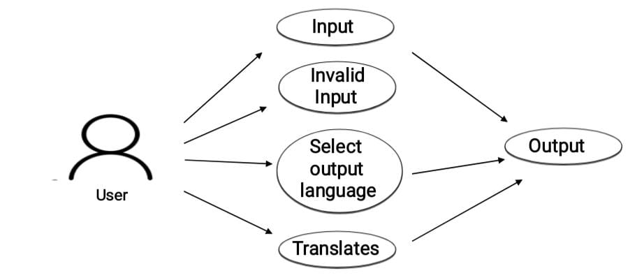

8

5.2 Use Case Descriptions

Use Case ID: UC01

Name: Gives Input

Actors: User

Description: Allows the user to give the input text.

Pre-Conditions: Give Input as Text and in English Language

only.

Post-Conditions: None

|  |  |
| --- | --- |
| User | System |
| 1.Gives the input text |  |
| 2.Selects the output language |  |
| 3.Clicks on Translate button |  |
|  | 4.Displays the output in desired language |

9

5.3 Activity Diagram

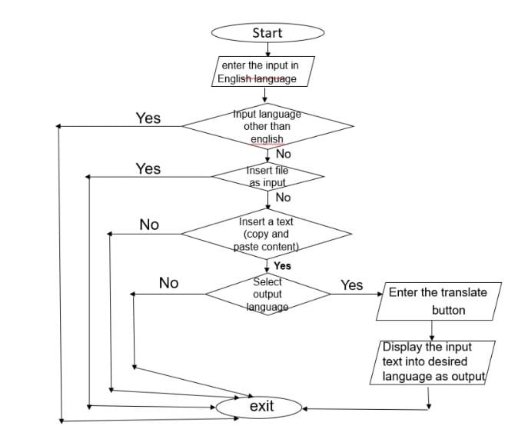

10

6.IMPLIMENTATIONS

Modules used

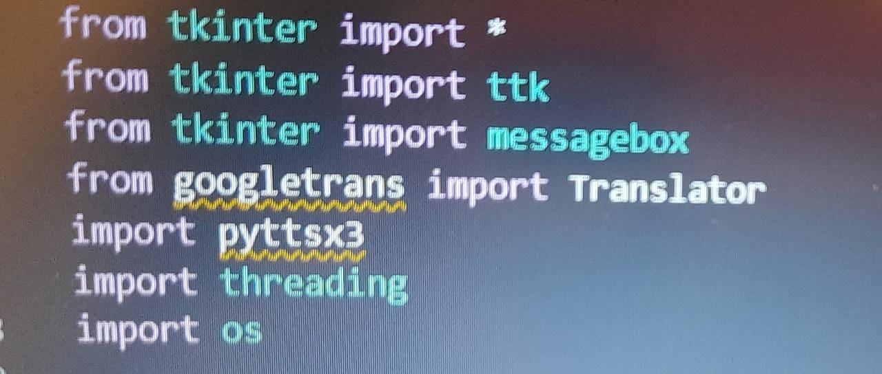

* These are the modules that are used in the project

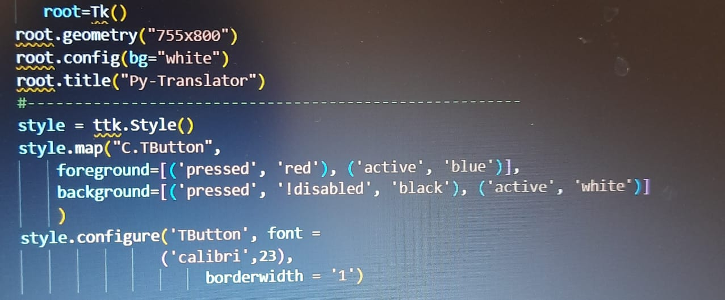

* Used to design the outlet or dialog box

11

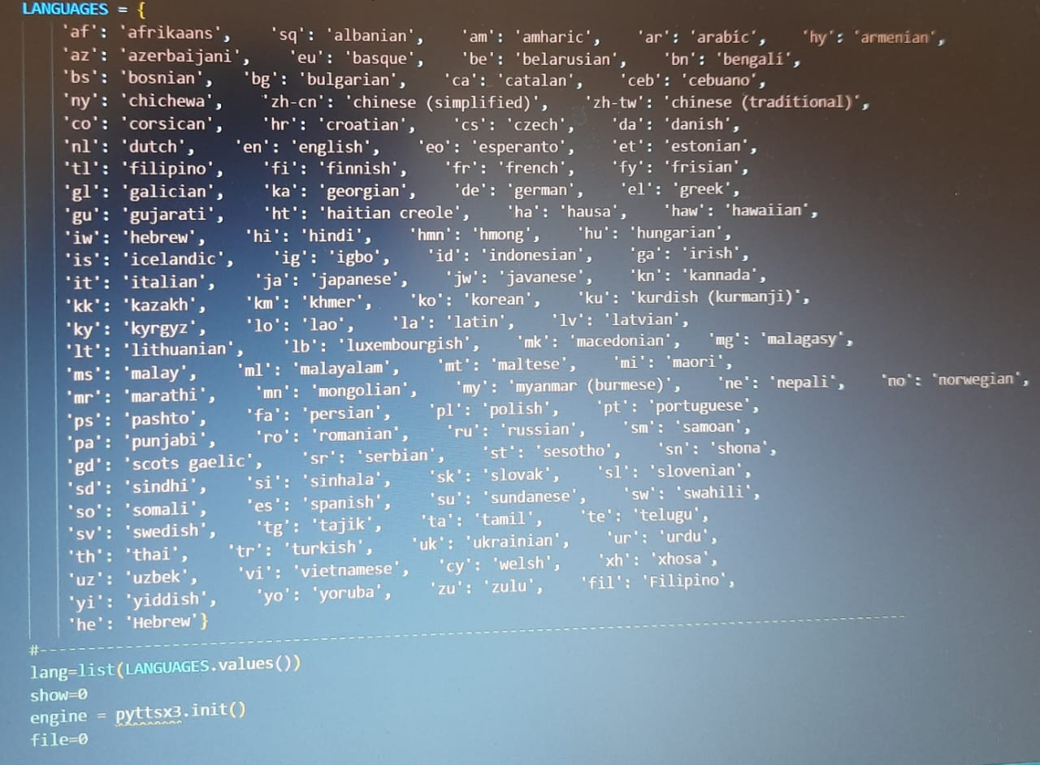

* This is the list of languages included in the project

12

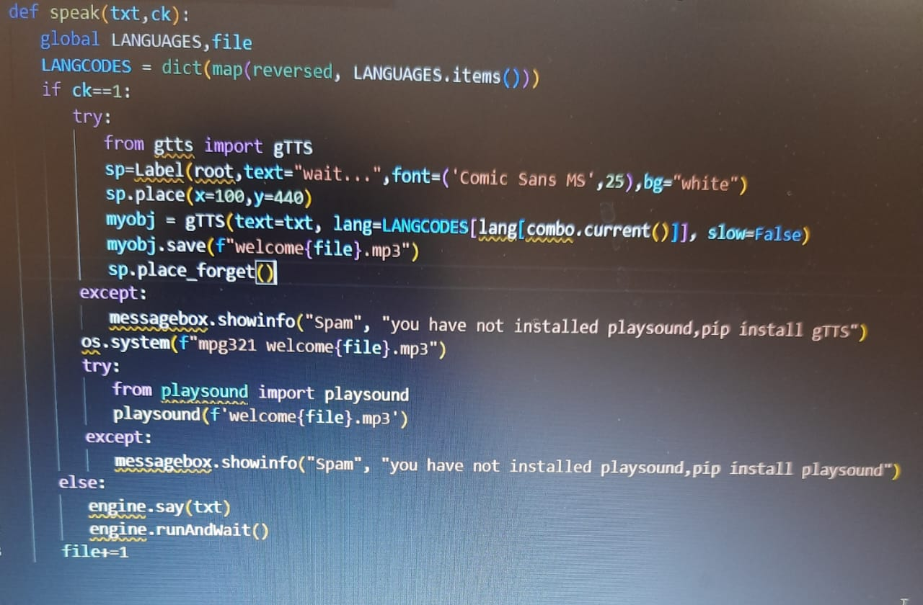

* Used to activate the audio for the given input Text and output text

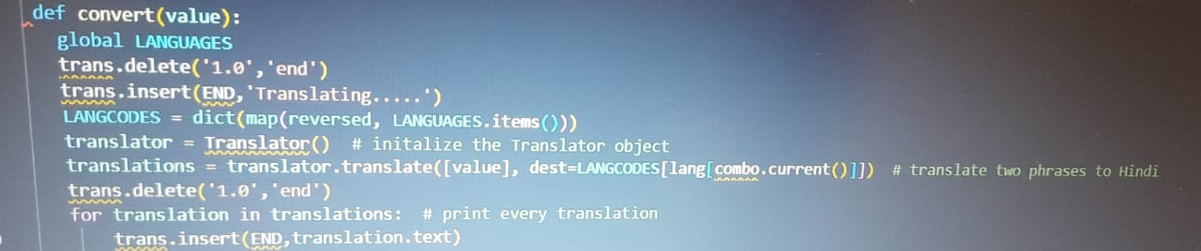

* This is the Convert method used to print the converted text.

13

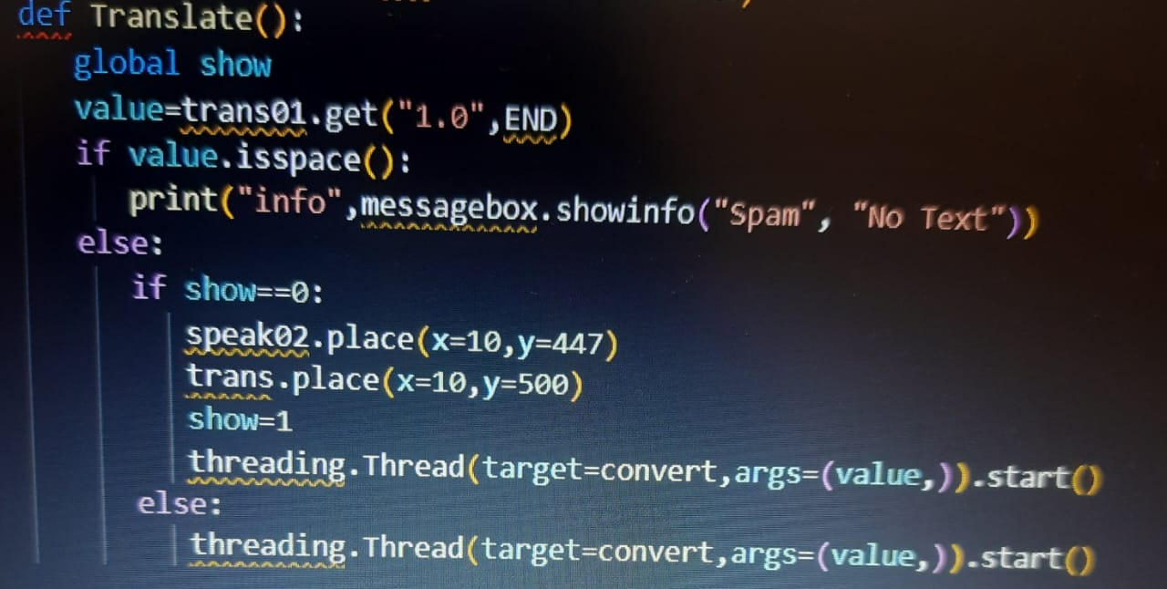

* Translation of input text into desired output language.

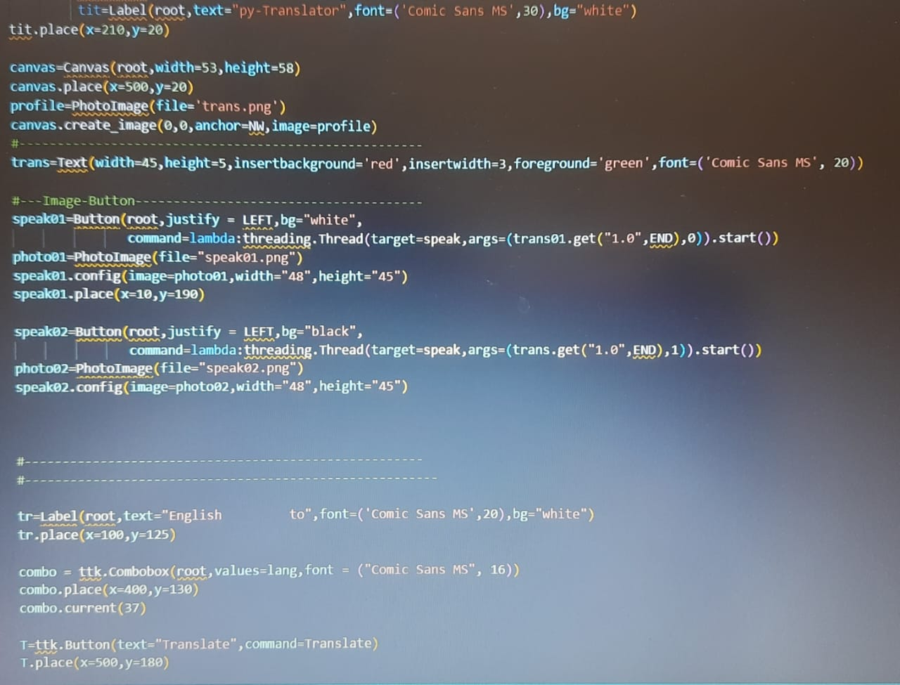

14

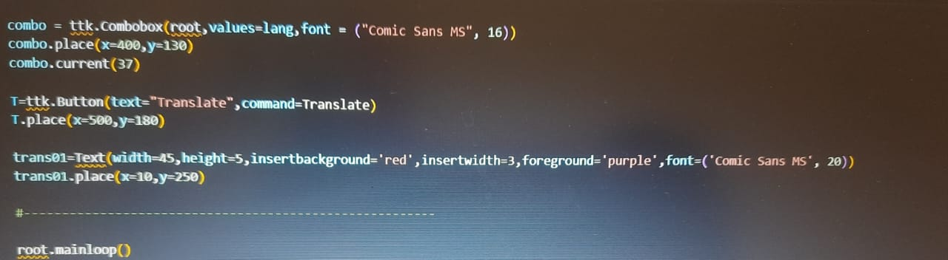

* Inserting the components of the Translation System like Voice images etc.

15

6.1 Execution of Program

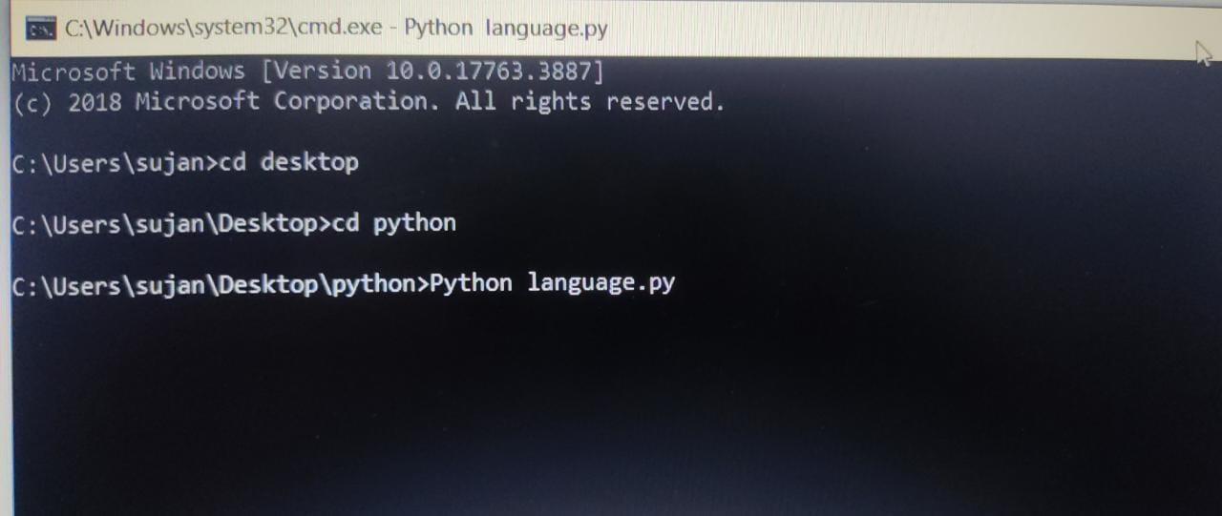

1.Compilation steps involved

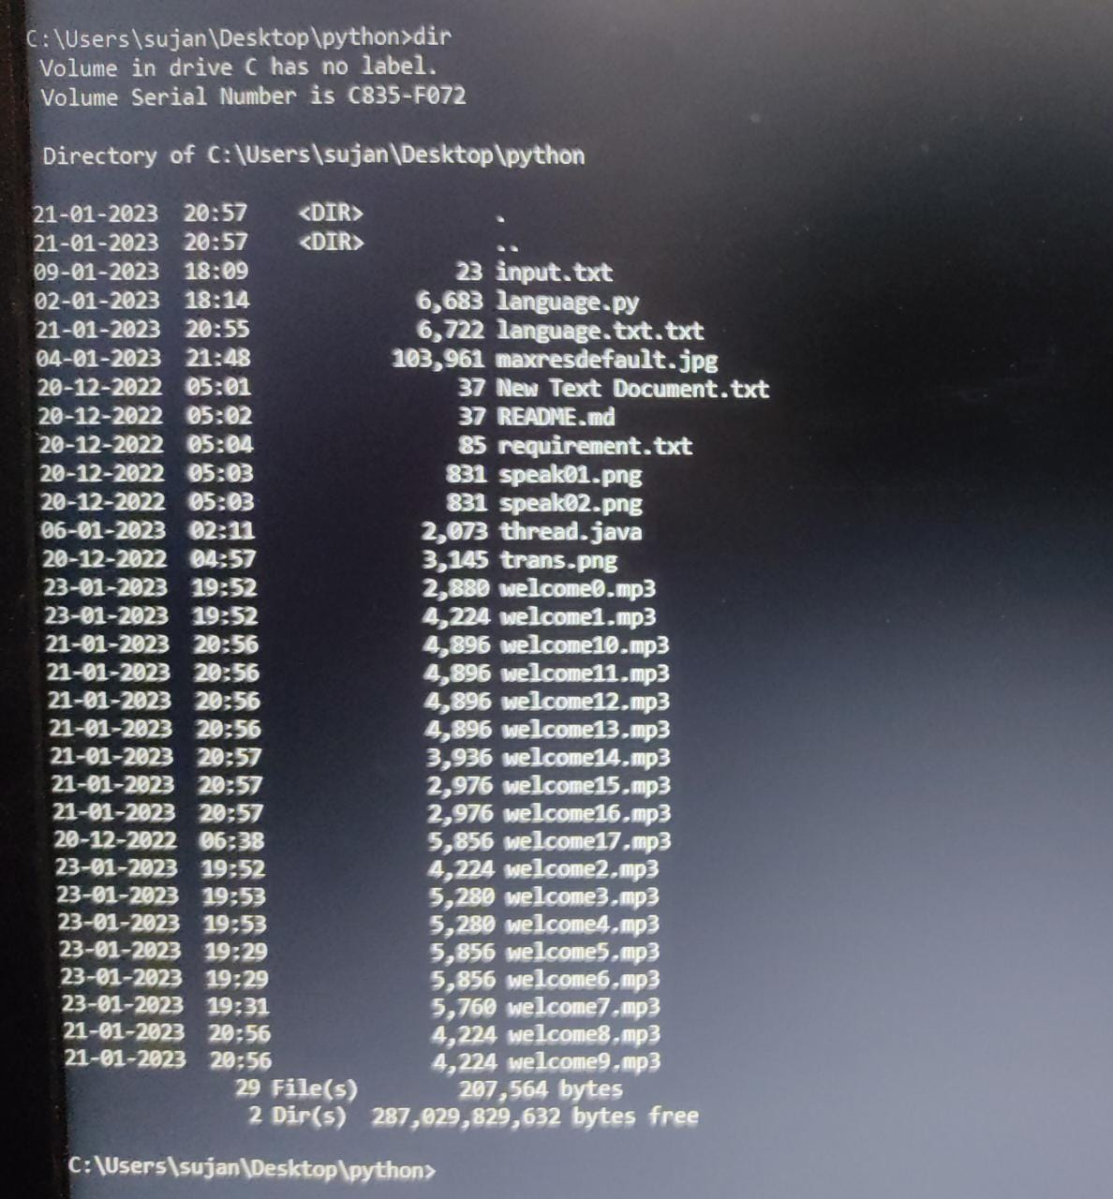

2.List of Files

16

6.2 Outputs

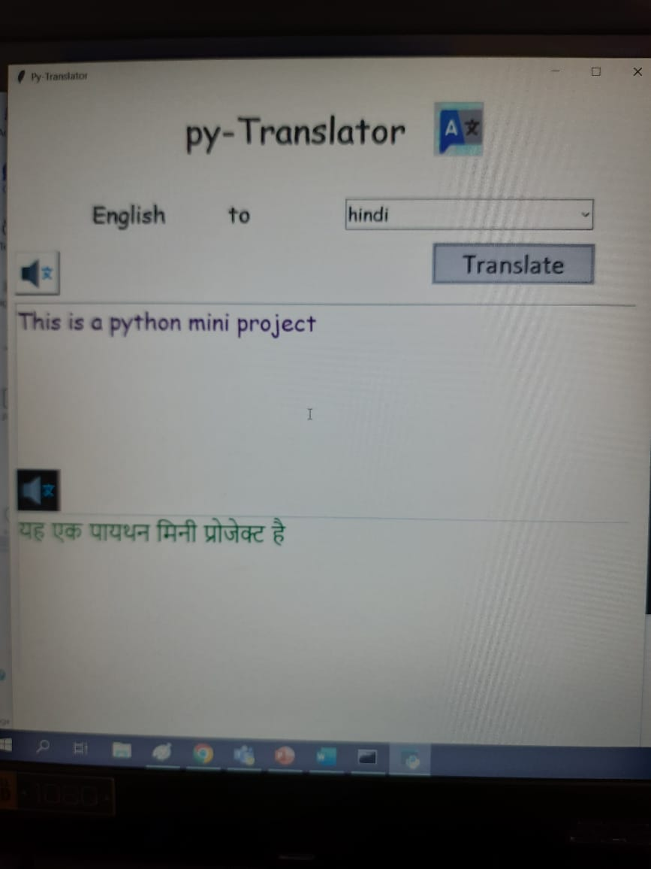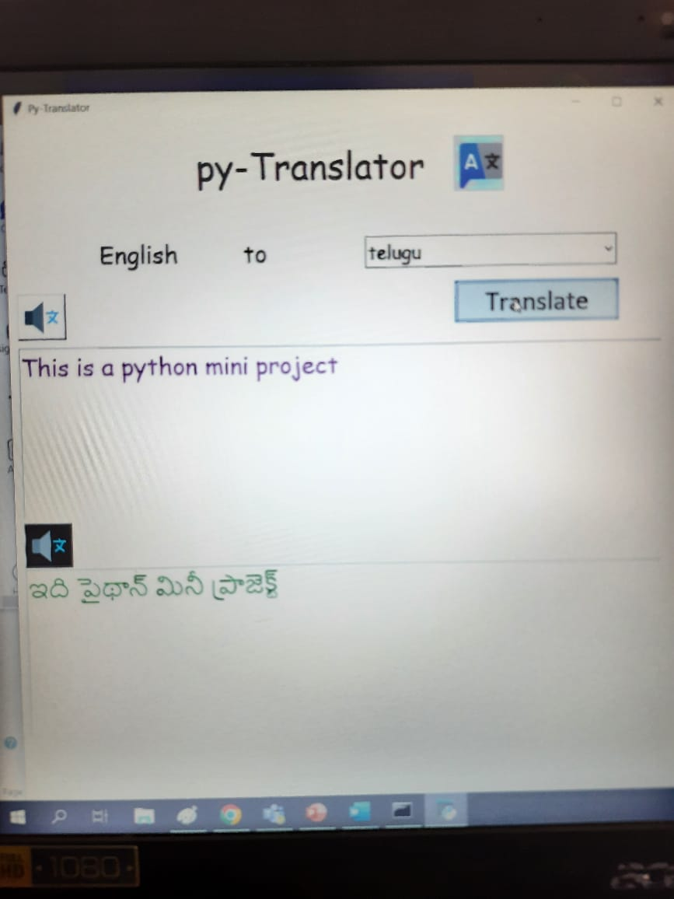

Output -1

Output-2

17

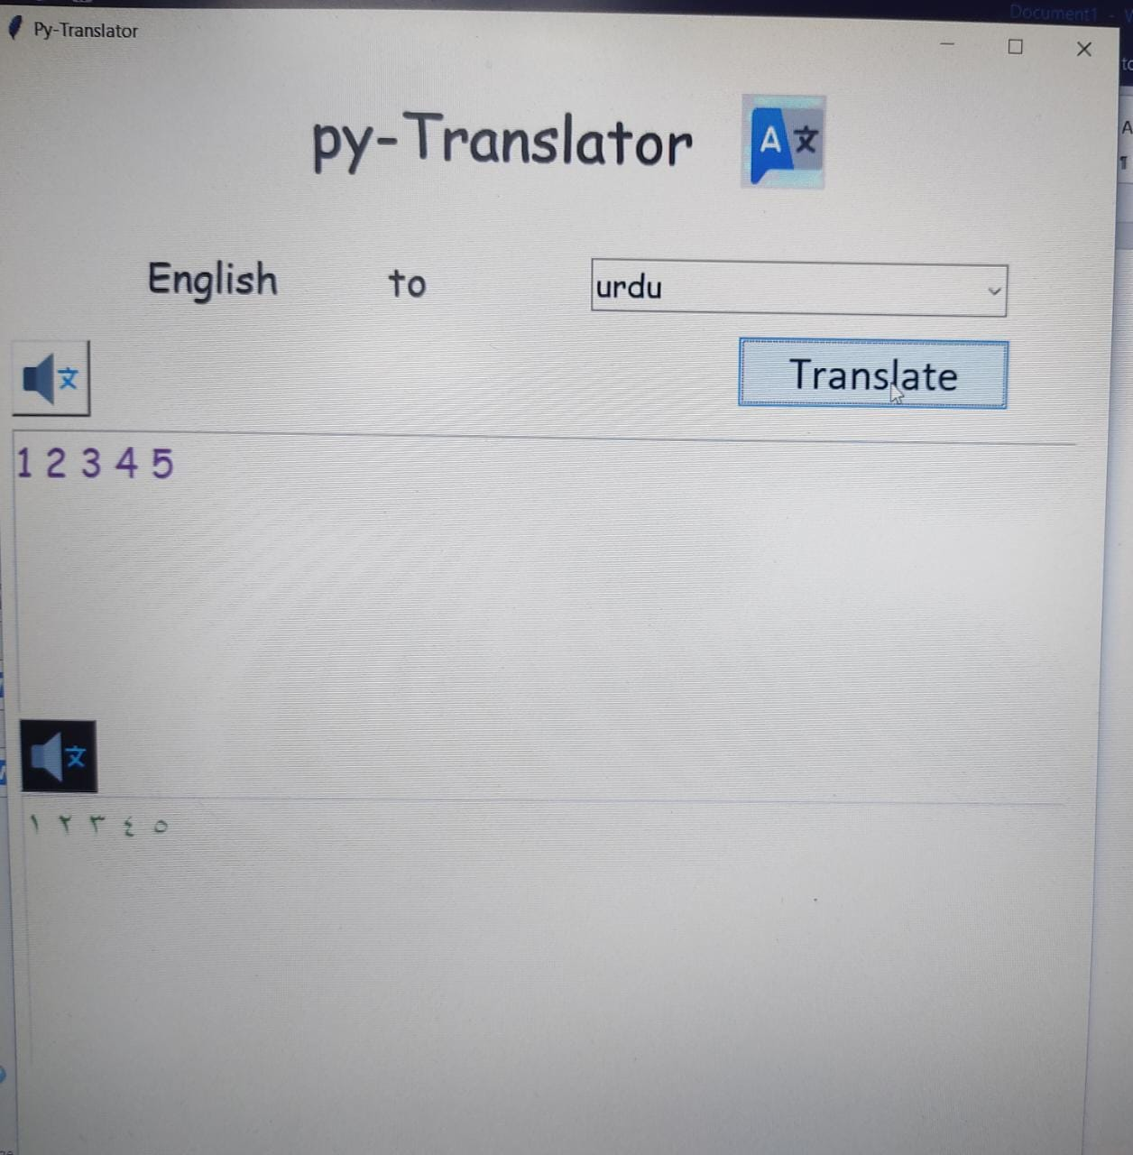

Output-3

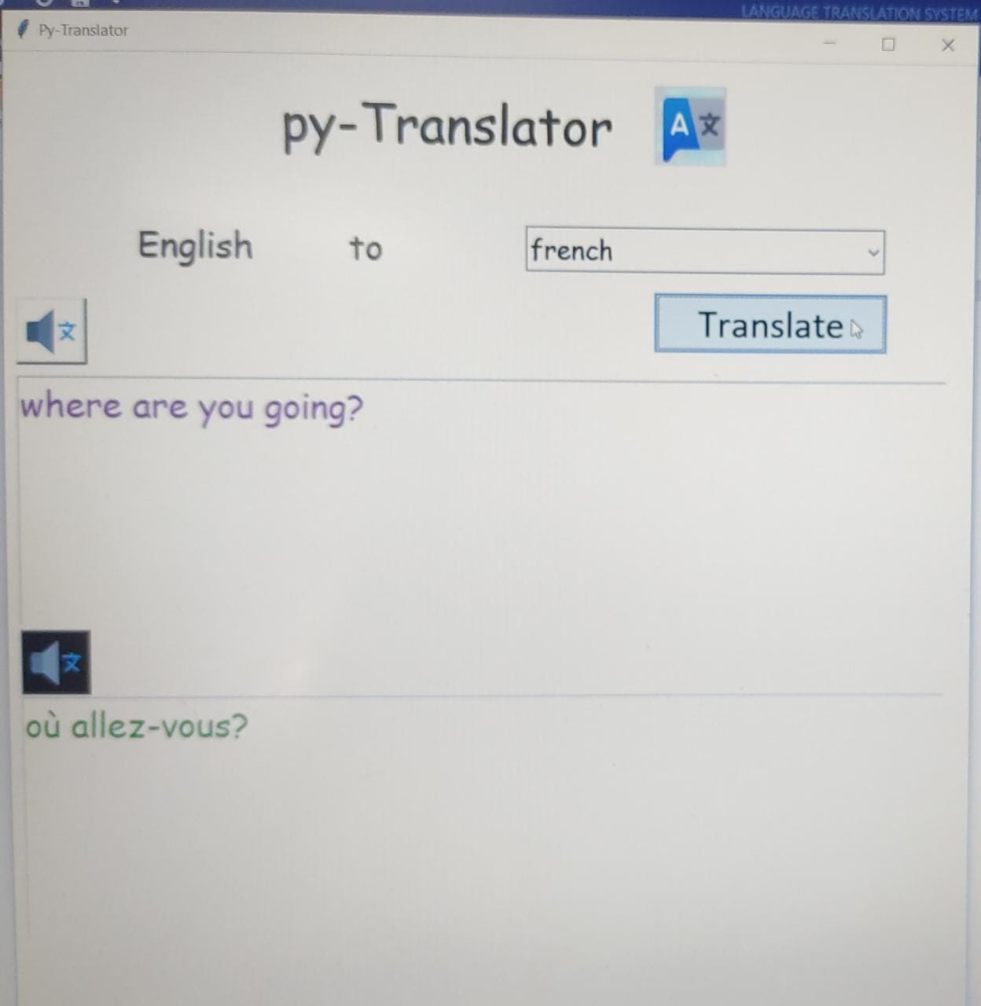

Output-4

18

7.ADDITIONAL KNOWLEDGE GAINED BY THIS PROJECT

7.1 ttk

That code causes several tkinter.ttk widgets (Button , Checkbutton , Entry, Frame, Label, LabelFrame , Menubutton, PanedWindow , Radiobutton , Scale and Scrollbar) to automatically replace the Tk widgets .This has the direct benefit of using the new widgets which gives a better look and feel across platforms. Ttk comes with 18 widgets, twelve of which already existed in tkinter: Button, Checkbutton, Entry, Frame, Label, LabelFrame, Menubutton, PanedWindow, Radiobutton, Scale, Scrollbar, and Spinbox. The other six are new: Combobox, Notebook, Progressbar, Separator, Sizegrip and Treeview . And all them are subclasses of Widget

7.2 MessageBox-

The tkMessageBox module is used to display message boxes in your applications. This module provides a number of functions that you can use to display an appropriate message. Some of these functions are showinfo, showwarning , showerror, askquestion, askokcancel , askyesno , and askretryignore.

7.3 Googletrans-

Googletrans is a free and unlimited python library that implemented Google Translate API. This uses the Google Translate Ajax API to make calls to such methods as detect and translate. Compatible with Python 3.6+

19

7.4 Translate-

Translate is a simple command-line tool and a Python module that enables you to perform translations using Google MT and other engines. It's quite similar to googletrans.

7.5 Theads-

Python threads are used in cases where the execution of a task involves some waiting. One example would be interaction with a service hosted on another computer, such as a webserver. Threading allows python to execute other code while waiting; this is easily simulated with the sleep function.

7.6 OS-

Python OS module provides the facility to establish the interaction between the user and the operating system. It offers many useful OS functions that are used to perform OS-based tasks and get related information about operating system. The OS comes under Python's standard utility modules.

20

8.CONCLUSION

In conclusion, language translation technology has come a long way in recent years and has become a crucial tool for facilitating communication and understanding between individuals and organizations . From machine translation systems to human-powered translation services, there is a range of options available to meet different needs and requirements. The technology has numerous practical applications, including facilitating cross-cultural communication, improving travel and education, and helping businesses expand into new markets. However, it is important to note that the accuracy of language translation can vary and it is always recommended to have translated text reviewed by a native speaker of the target language.

Looking to the future, we can expect to see continued advancements in the field of language translation, including increased accuracy, integration with other technologies, and the development of more personalized and intuitive translation systems. Ultimately, the continued growth and development of language translation technology holds great promise for enhancing communication and understanding across cultures and language barriers.

21

9.FUTURE SCOPE OF THE PROJECT

The future of language translation technology holds significant promise and potential for growth and development. Here are a few areas where we can expect to see advancements:

1.Increased Accuracy: With the advancement of AI and NLP algorithms, the accuracy of machine translation systems is expected to continue to improve, making them more reliable and useful for a wider range of applications.

2.Integration with other technologies: Language translators will likely become more integrated with other technologies such as virtual and augmented reality, making them more accessible and useful in a variety of settings.

3.Multimodal Translation: There will be an increasing demand for

translation systems that can handle multiple modes of

communication, such as text, speech, and gestures, making

4.Real-time Translation: Real-time translation technology is

expected to continue to evolve and become more widely available,

making it possible for individuals and businesses to communicate

in real-time across language barriers.

5.Customized Translation: With the rise of customization in all

areas of technology, we can expect to see more language

translation systems that can be customized to specific industries,

or personal preferences, making them more effective and user-

friendly.

Overall, the future of language translation technology holds great promise and the potential to greatly enhance communication and understanding across cultures and language barriers.

22

10.REFERENCE WORK

1. <https://www.geeksforgeeks.org/python-gui-tkinter/>
2. <https://www.geeksforgeeks.org/language-translator-using-google-api-in-python/>

1. <https://www.geeksforgeeks.org/python-text-to-speech-by-using-pyttsx3/>

4. [Convert Text to Speech in Python - GeeksforGeeks](https://www.geeksforgeeks.org/convert-text-speech-python/)

23